Ranking models

- Boolean models and its extensions

The Boolean model and its extensions based on the set theory and Boolean Algebra. In the Boolean model, the terms either exist (in other words, have the weight 1), or don’t exist (in other words, have the weight 0). The query expressions based on the Boolean Algebra and its operators: and, or, not.

Advantages:

1) The easy implementation in the systems and clear formalization behind the expressions;

2) The easy calculation of the document similarity to the query. If every conjunctive component of the query is equal to the conjunctive component of the document, the documents are similar to each other, and sim(d_{j}, q) = 1. As a result, user gets the desired results.

3) It is fast in small set of documents.

Disadvantages:

1) The retrieved documents are not ranked. In this case, it is impossible to know which document has the highest relevance.

2) The results might have the only documents that is exactly match with the query expression. In other words, the partial matches are not retrieved by the Boolean model. As a result, the term might appear once or several times, which doesn’t change the result of query. In addition to this, the users usually don’t write complex queries.

3) Irrelevant in the large set of document. Firstly, it might be very slow. Secondly, it might retrieve either very few documents or a lot of documents.

One of the possible extensions is Extended Boolean Model. It uses the Vector Space Model elements, such as weights and vectors, and combines them with the Boolean Model, solving some problems described in the disadvantages. In the Extended Boolean Model, each term k_{x} of the document d_{j} has the weight:

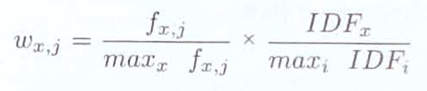

w_{x,j} = (f_{x,j}/max_{x}(fx,_{j})) * (IDF_{x} / max_{i}(IDF_{i}))

In the two-dimensional space with two terms, there are two possible cases:

1) for distinctive query, q_{or} = k_{x} ∨ k_{y} , The starting point of k_{x}-k_{y} coordinate plane be taken as (0;0), because it is the least interesting one. The similarity can be calculated as

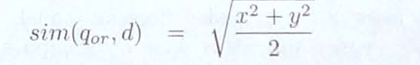
2) for conjunctive query, q_{or} = k_{x} ∧ k_{y} , The starting point of k_{x}-k_{y} coordinate plane might be taken as (1;1), because it is the most interesting one. The similarity can be calculated as

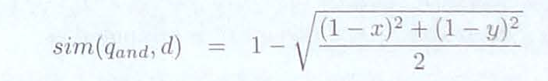

The additional advantage of Extended Boolean Model is that p-norm distances of document vectors could be used instead of Euclidean Distance, where 1 ≤ p ≤ ∞. In that case, for the disjunctive queries
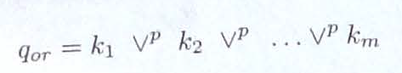
and conjunctive queries
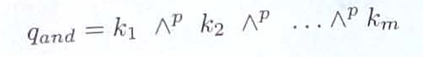

the similarity might be calculated as

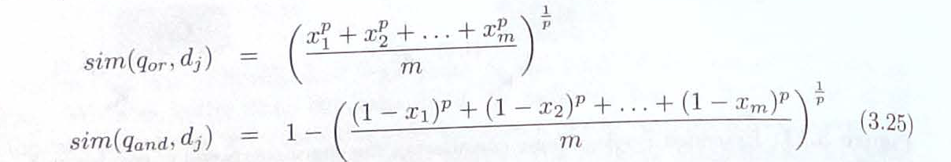

if p = 1, the similarity can be verified as

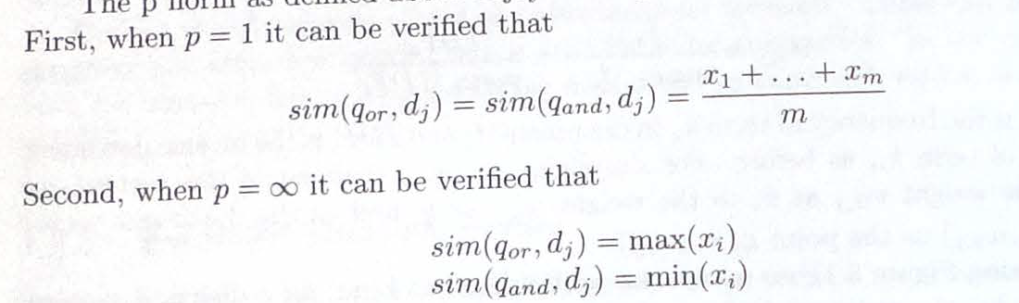
else if p = ∞, the similarity can be verified as

The second possible approach is creating the termsets and checking the vocabulary-set for every possible subset of the terms. In this case, the problem is the possible number of subsets, which is equal to 2^{t}, where t is a number of terms in the termset. To avoid this, n-termsets might be used, where all n-1 termsets are frequent. The calculation of the ranking for the termsets are similar to the vector model terms:
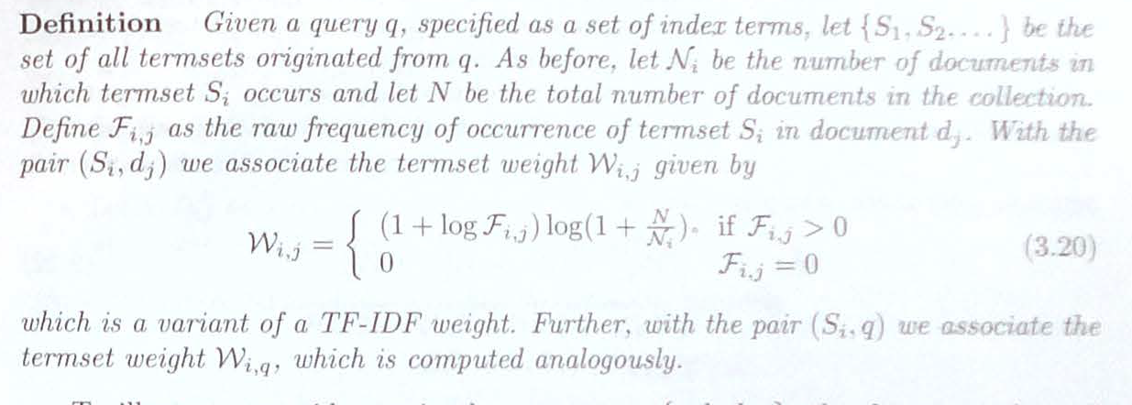

As a result, the cosine similarity is also calculated similar to the similarity in Vector model:

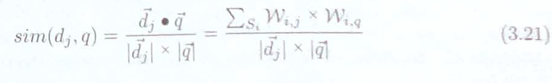

Another possible approach is using the Fuzzy set theory, where the term relationships are defined with the correlation matrix, where an element ci,j is defined by

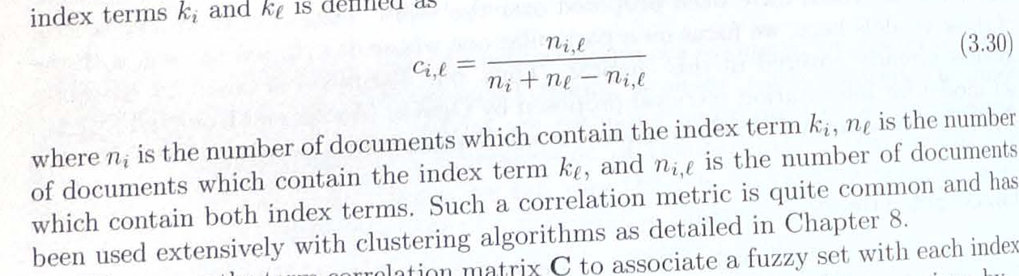
Hence, the degree of membership that receives the value in the interval [0;1], is calculated by
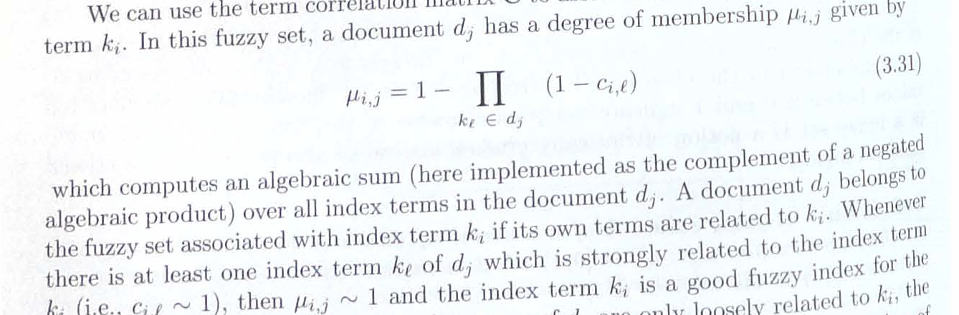

- Vector space models and its extensions

In the Vector Space Model, every query and every document is represented as the vector dj = {wj1, wj2,…,wjn}, where wj1, wj2,…,wjn are the non-binary and non-negative weights of each term.

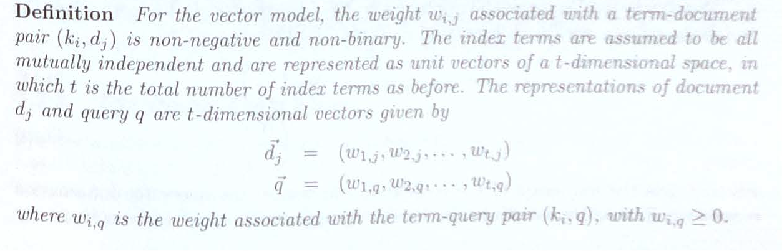
In this case, the cosine similarity between a query and a document might be calculated as

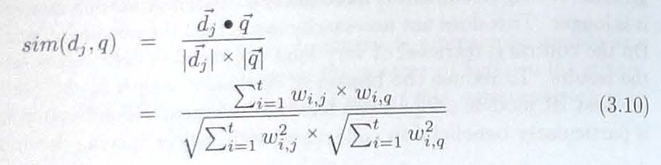

The advantages of the vector model:

1) Term-weighting scheme improves retrieval quality of queries;

2) As a result, it provides the partial matching strategy that retrieve the documents approximately matching query conditions.

3) The sorting of documents by the value of cosine similarity to the query

4) It provides the length weight normalization, which helps to build-in the reliable ranking.

The disadvantages of the vector model:

1) In the huge collections, the calculation of rankings are slow.

2) The partial matching could provide the results with low weights.

One of the extension of the Vector Model is the Generalized Vector Model, which assumes that the index vectors are not orthogonal, but composed of smaller components derived from the collection by hand. The main idea is to creating the unique vector for the document which doesn’t exist in other documents.

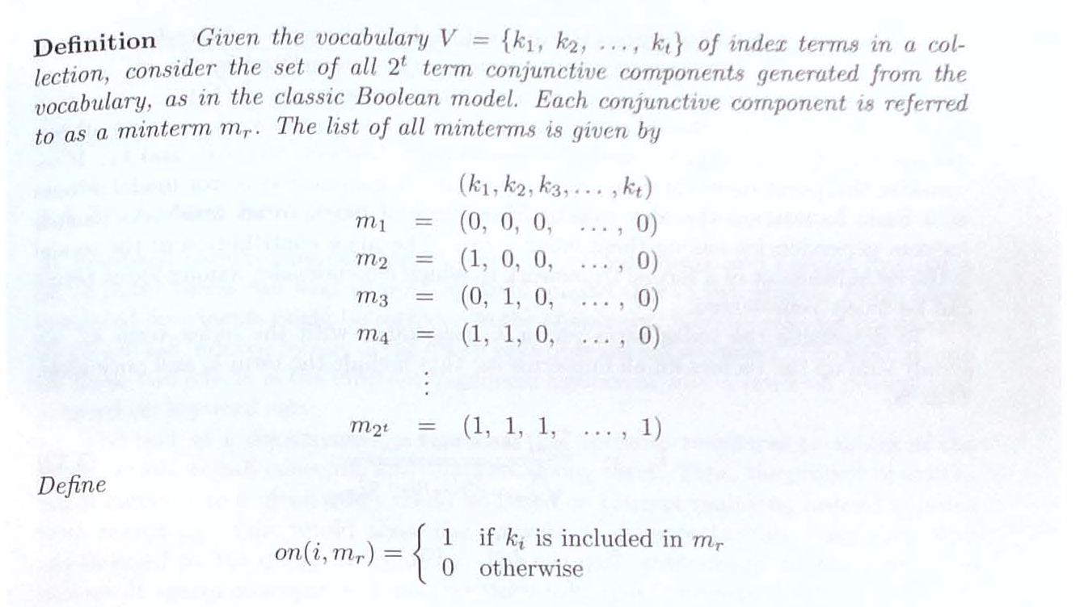
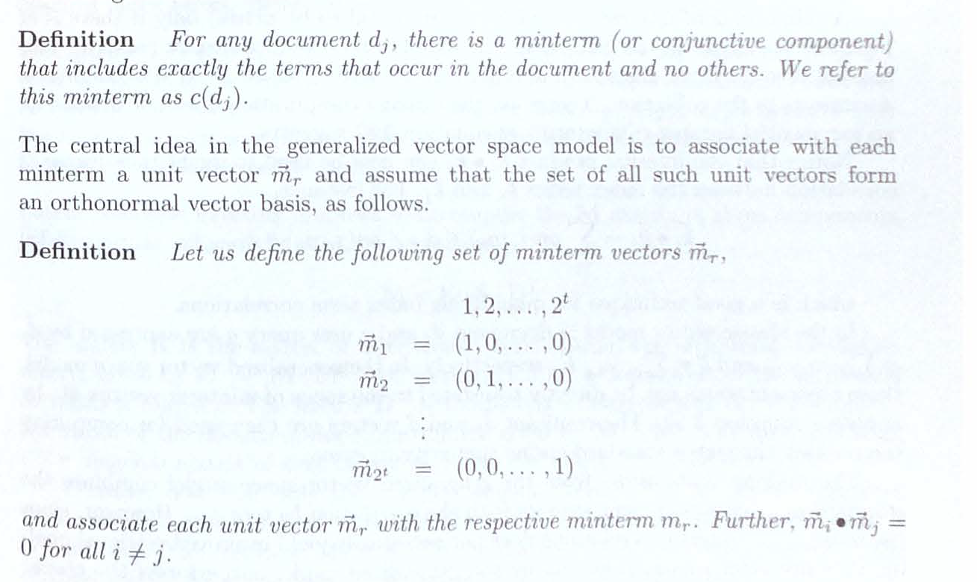

In this case, the index term vectors are calculated as
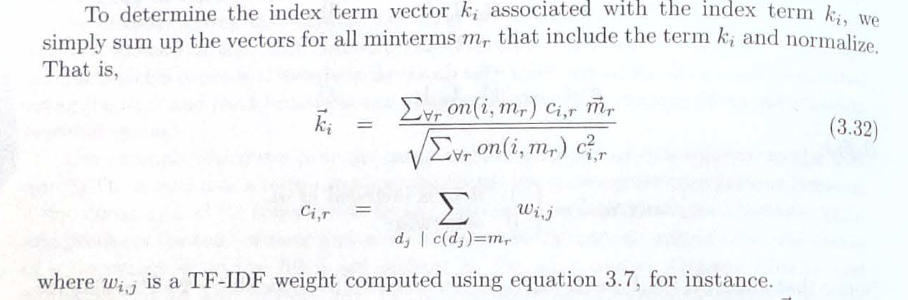
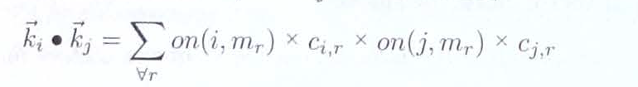

Despite the model might give more exacter results, it is also slow in the huge collections.

Another possible solution is using the Neural Networks Model. It is based on the signals between query nodes, a document vocabulary, and the document nodes. After each iteration, the signal become weaker. To calculate the activation level of the document node associated with the document d_{j}, the formula below is used:

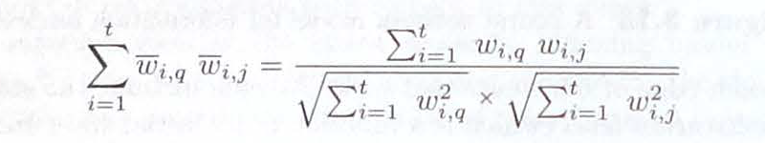

- Probabilistic models and its extensions.

The idea of The probabilistic model is to create the probabilistic description of the ideal answer set that matches to the query. For this reason, the results of cooperation between users that decide the relevancy of a document and the system might be used.
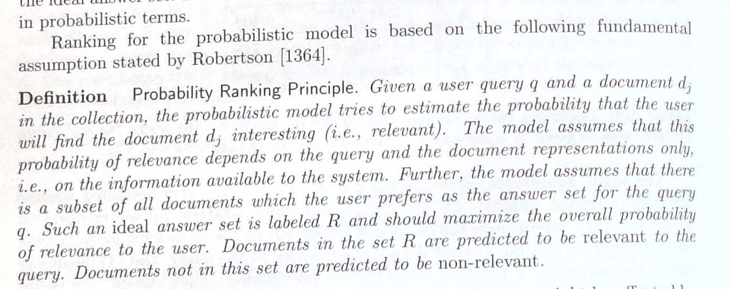

For the query q, the ratio P(dj relevant-to q) / P(dj non-relevant-to q). In this case,
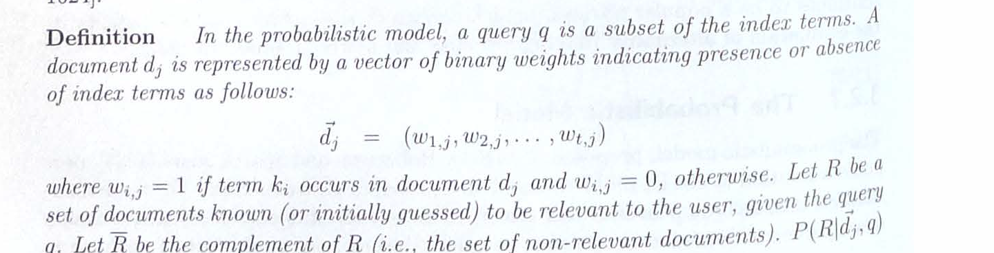

and the similarity is calculated by
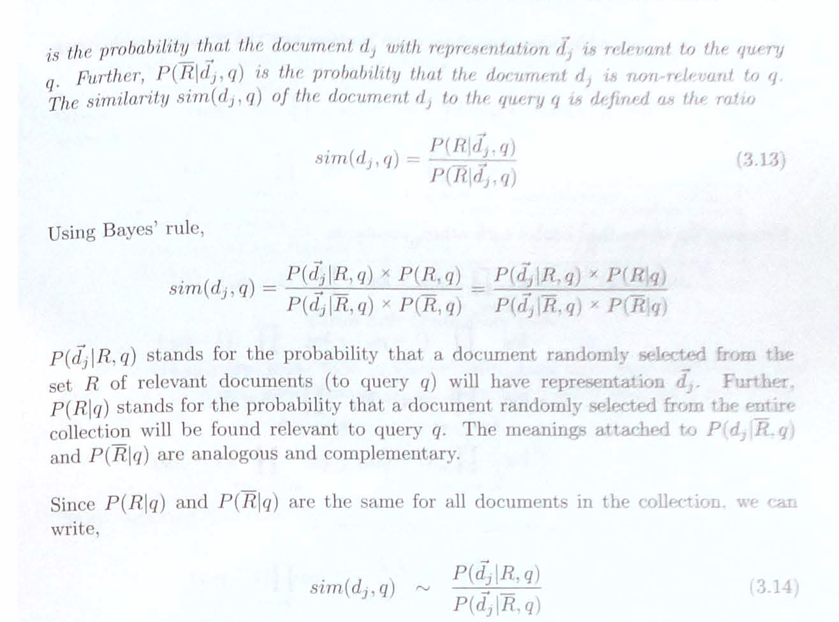

The advantage of the probabilistic model:

1) The documents are ranked with the decreasing order of the probability.

The disadvantages of the probabilistic model:

1) It requires the user intervention to define what documents are relevant;

2) The weights document vector based on the fact if the keyword exists or not. As a result, like Boolean Model, it doesn’t count how many times the word is used in the document.

3) The length of a document is not normalized.

One of the possible extension is to use the Bayesian Network Models. It is based on the relationships between the nodes of acyclic graph, where arcs describes the strength between nodes with random values.
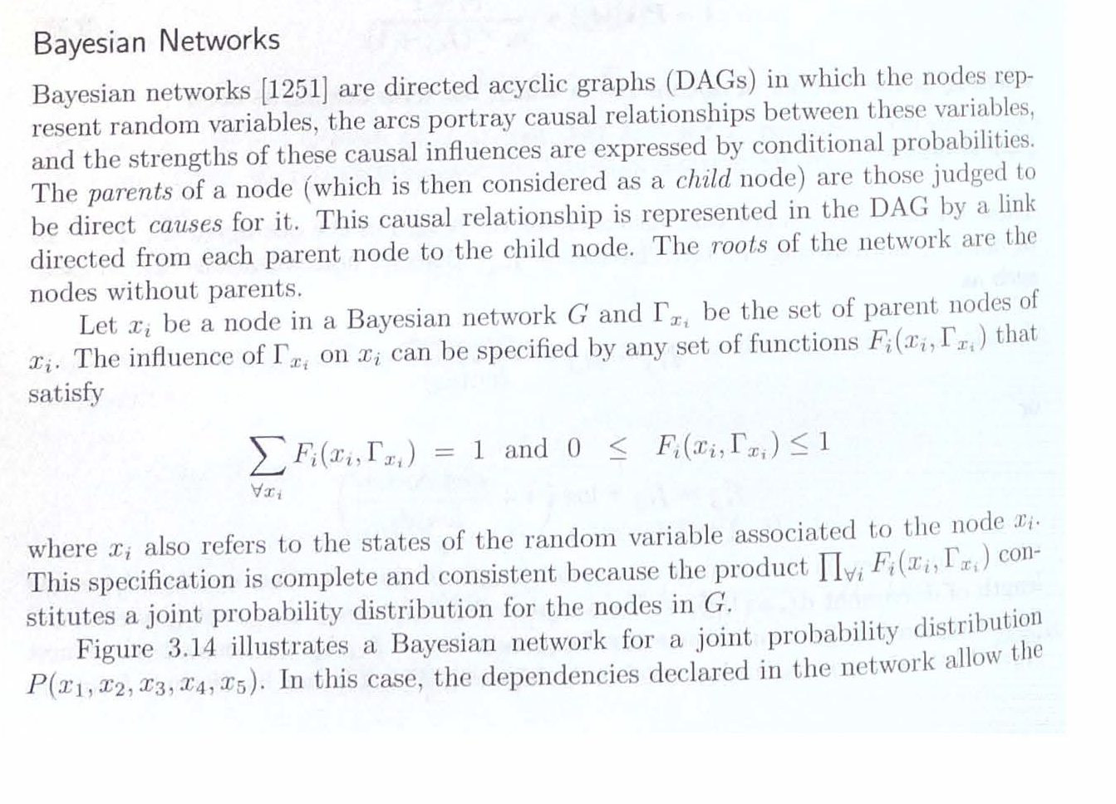
The method of the author:

Analyzing the models, author provides the Elo Model. The Idea is to compare the documents against each other to define the probability between the documents. The first parameter is the number of terms in documents, which should be compared. The second parameter is the length of the document. By comparing all documents in all terms, the Elo’s should be calculated by the formula.

Elo in the term = W + log2L

Total Elo of the document = Average of ELOs in the terms.

In the Boolean OR, NOT expressions, the highest values of term ELOs of the document containg the term should be retrieved. If ELOs in the terms are Equal, the highest total Elo should be retrieved. In the AND queries, if there are several documents satisfying the query, the average ELO is calculated by:

Total of ELOs of documents in AND operations
Average ELO = ---------------------------------------
1 + Number of consecutive AND operators

The advantages:

1) The document with the highest count of a term will be retrieved.

2) In the equal conditions, the documents with higher length will be retrieved.

The disadvantages:

1) The bitmap of each document comparing to the total vocabulary should be calculated.

2) The ELO Calculation in the huge systems might be time-consuming.

